Enterprise Business Process | Leave blank for now | Last Updated Date | 06/26/2019
Written/Revised By | Braeden Haesemeyer | Control # | Leave blank for now
Process Owner |  | Revision | 1.0
Purpose
The purpose of this guide is to demonstrate how to request adjustments to your schedule for the following reasons:
- Personal time off (PTO)
- Overtime
- Bereavement
- Illness
- Adjust Hours

Detailed Steps/Screen Shots
# | Topic | Notes
 | Go to the OCC Sharepoint | This is the link here: http://app38-02.optum.com/sites/ESSWorkforce/OCC/SitePages/Home.aspx
 | Click “Schedule Adjustments". | This link is located on the lower left on the OCC Home Page  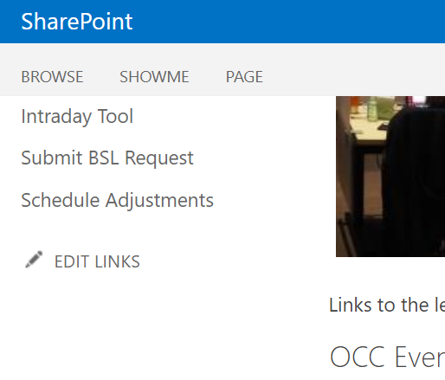  If you cant find the link click here to open the form.  This form should appear  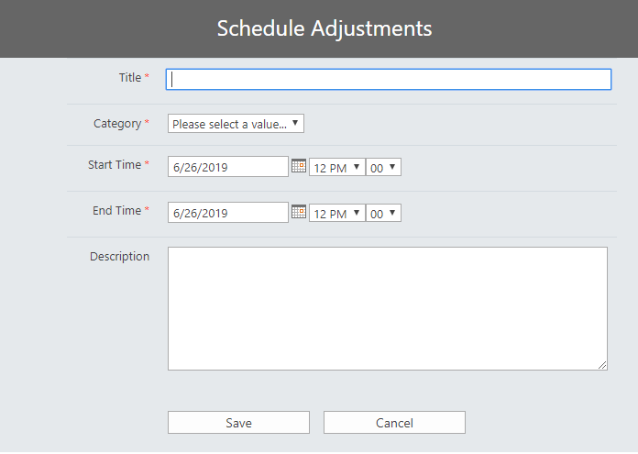
 | Fill out the title. | This is what will be displayed on the calendar. We recommend your title be “Your Name – Category”. There is a 45 character limit on what you can put here.
 | Select the category. | Select PTO if you are requesting time off that will be coming out of your paid time off.  Select Overtime If you are requesting to add overtime hours.  Select Bereavement if you are requesting time off to attend a funeral, or other related circumstances.  Select Illness if you are requesting time off because you are sick.  Select Adjust Hours if you are requesting to adjust the hours you will work.
 | Enter the start time. | For PTO, Bereavement and Illness, this will be the start time of when you will be out of the office.  For Overtime, this will be the start time of any hours that are beyond your traditional schedule.  For Adjust Hours, this will be the time that your adjusted shift will begin.
 | Enter the end time. | For PTO, Bereavement and Illness, this will be the end of when you will be out of the office.  For Overtime, this will be the end time of any hours that are beyond your traditional schedule.  For Adjust Hours, this will be the time that your adjusted shift will end.
 | Enter a description. | Enter a justification for your schedule adjustment. This should be at a very high level – everyone on the team will be able to view this. If you feel that your request needs a further justification please include that in an email to your supervisor after your submit this request.
 | Click save. | Click save to submit this form and send an approval email to your supervisor.
 | The calendar view | Once you click save or cancel, the form will disappear and you will see a calendar with everyones requests. Your request will appear in grey; this is because it has not been approved yet. Once approved your request will change to its appropriate color. If your request is rejected it will disappear in this calendar view.
Revision History
The following are approved changes incorporated into the revision numbers indicated below.
Revision | Date, Description of Change, and Name
1.0 | 06/26/2019: New by: Braeden Haesemeyer

